**Class Project 2**

Use two images for each operation to do the following operations and write down their advantages and disadvantages and explain your results:

1. **Image translate(lena, bridge):**

* Alternative line reduction

**Algorithm:**

First, judge the offset of x and y, and perform arithmetic calculations on each of the six cases.

It is defined that the positive value of x is the overall shift to the left, and the negative value is the shift to the right. It is defined that the positive value of y is the overall downward shift, and the negative value is the upward shift.

(According to different situations, apply the same algorithm).

i=0, i < imageheight, i plus 1

j = 0, j < imagewidth, j plus 1

after offset, in have pixels area:

$$outimagedata=inimagedata(\left(i+y\right)*imagewidth+j+x)$$

other area:

$outimagedata=0$ (set to black)

**Results (including pictures):**

Result of processing “Lena.pgm”:

Source Image: Result after image translate:

(x = 100, y = 0)

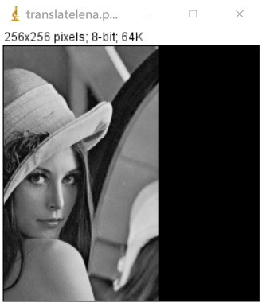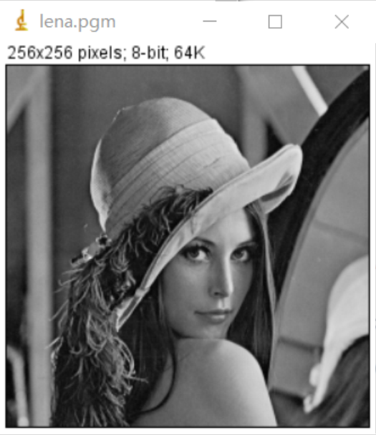

Result of processing “bridge.pgm”:

Source Image: Result after image translate:

(x = -100, y = 100)

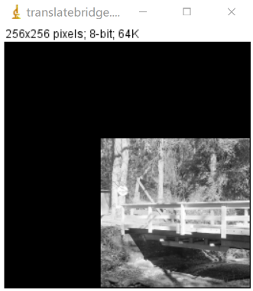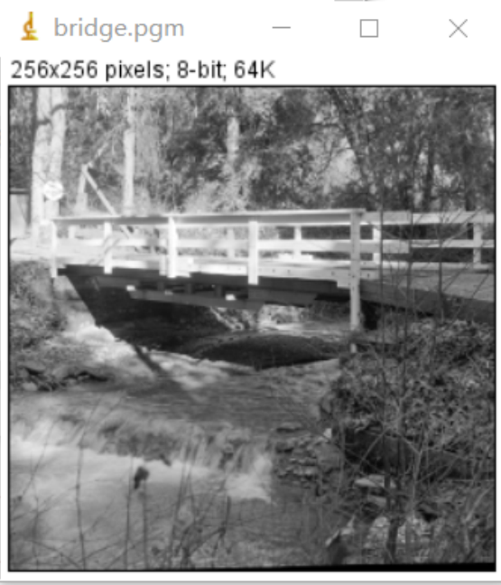

**Discussion:** For the free pixels after the offset, set to black "0". Assign the points of the input picture to the output picture according to the offset of the remaining points.

**Codes:**

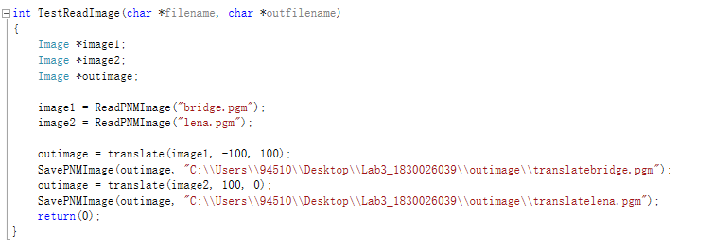

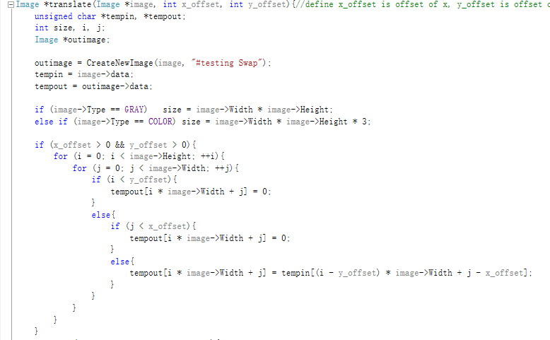 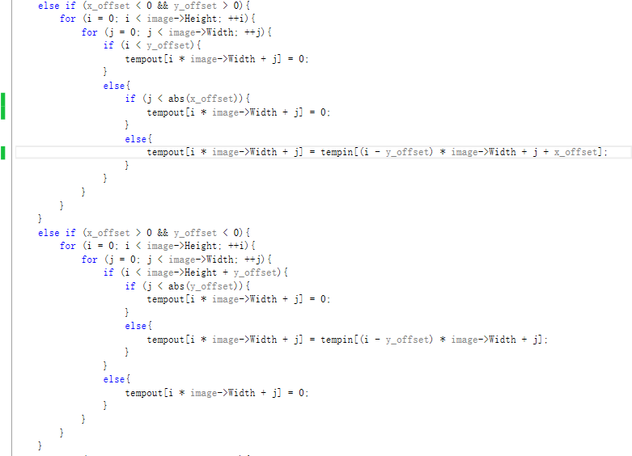 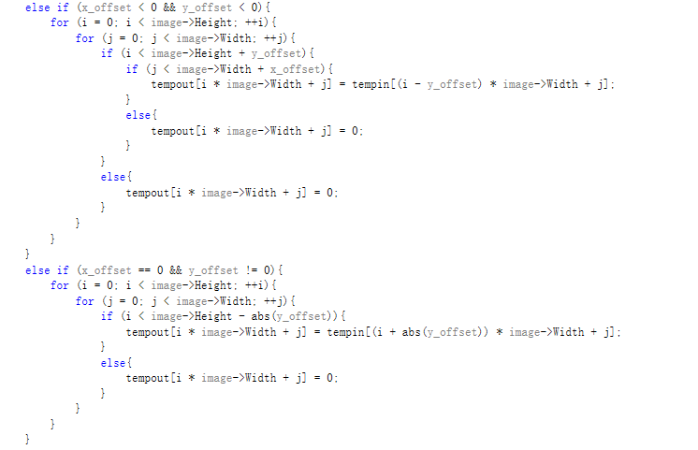 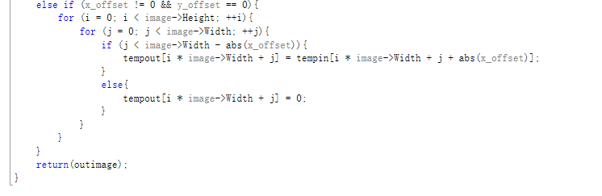

1. **Image rotation(lena, bridge):**

**Algorithm:**

Set the origin to the center point of the image.

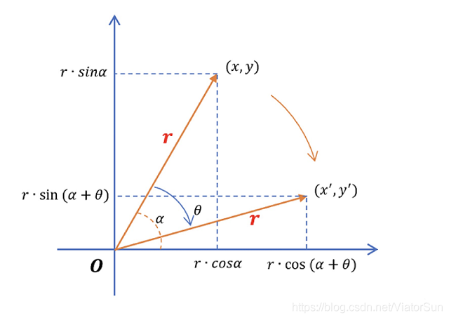 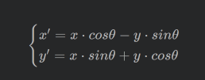

midx = width / 2

midy = height / 2

angle is the theta you want to rotate.

i = 0, i < imageheight, i plus 1

j = 0, j < imagewidth, j plus 1 $$outimagedata=0 (set all pixels to be black)$$

i = 0, i < imageheight, i plus 1

j = 0, j < imagewidth, j plus 1

after_i = i – midx

after_j = j – midy

pre_i = cos(angle) * after_i – sin(angle) + midx

pre_j = sin(angle) * after_j + cos(angle) + middy

check if pre_i is bigger than or equal to 0; pre_i is smaller than height;

pre_j is bigger than or equal to 0; pre_j is smaller than width $$outimagedata=inimagedata[pre_i*width+pre_j]$$

**Results (including pictures):**

Result of processing “Lena.pgm”:

Source Image: Result after image rotation:

(90 degrees)

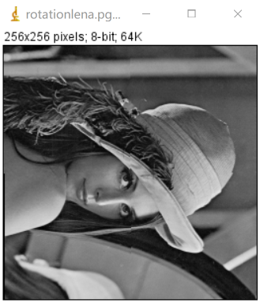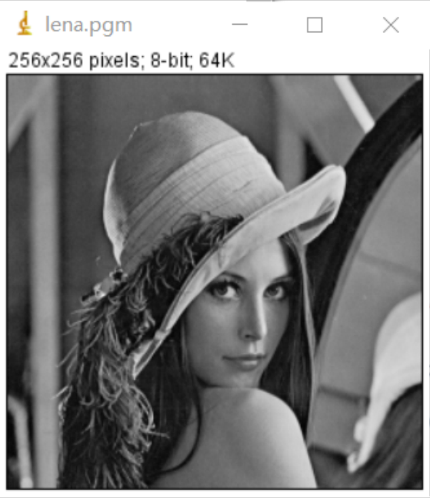

Result of processing “bridge.pgm”:

Source Image: Result after image rotation:

(10 degrees)

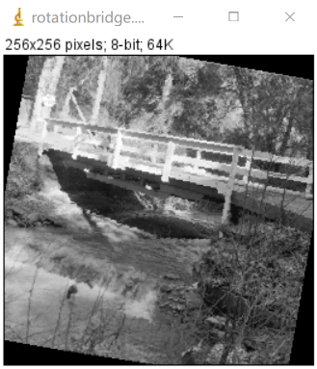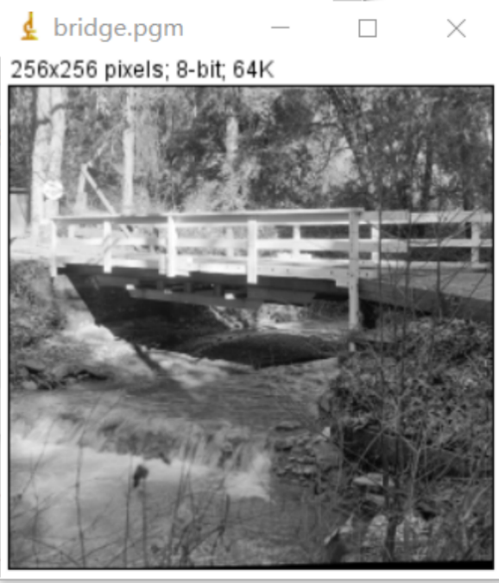

**Discussion:**

Set all the predetermined values ​​of the output image to black, and perform the angle calculation of the original image and assign values ​​to the output image for the position that has been reset after rotation.

**Codes:**

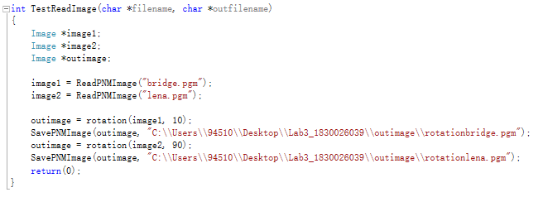 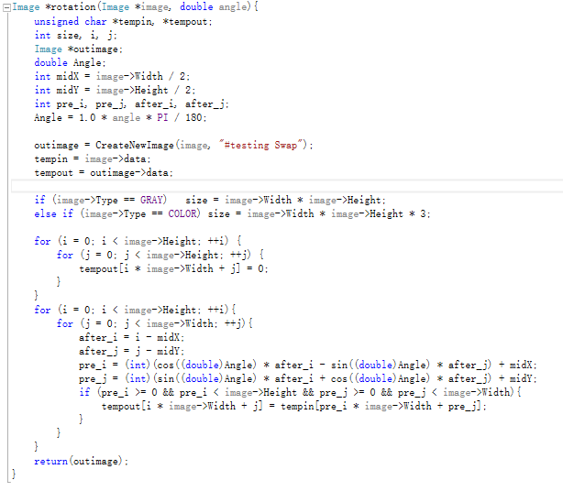

1. **Image shear(lena, bridge):**

* Shear X

**Algorism**

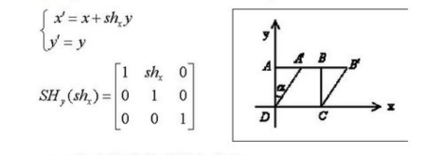

Enlarge the width.

ratio is the magnification you want to shear.

Outimagewidth = inimagewidth + inimageheight * |ratio|

i = 0. i < imageheight, i plus 1,

if ratio is greater than or equal to 0,

j = 0. j < imagewidth, j plus 1,

res_h = i,

res_w =j,

outimagedata[res_h*outimagewidth + res_w] = inimagedata[i * imagewidth +j]

else

offset = |ratio| * imagehight,

j = imagewidth -1, if j is greater than or equal to 0, j minus 1,

res_h = i,

res_w = j,

outimagedata[res_h*outimagewidth+res_w+offset]=inimagedata[i * imagewidth +j]

**Results (including pictures):**

Result of processing “Lena.pgm”:

Source Image: Result after image shear X: (-0.5 times)

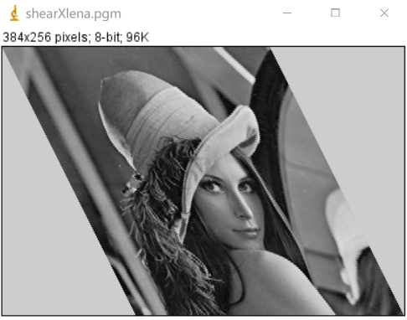

Result of processing “bridge.pgm”:

Source Image: Result after image shear X: (0.5 times)

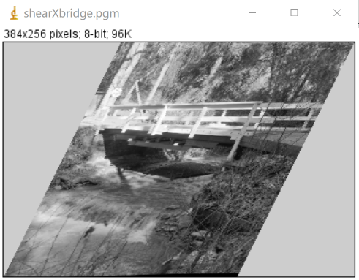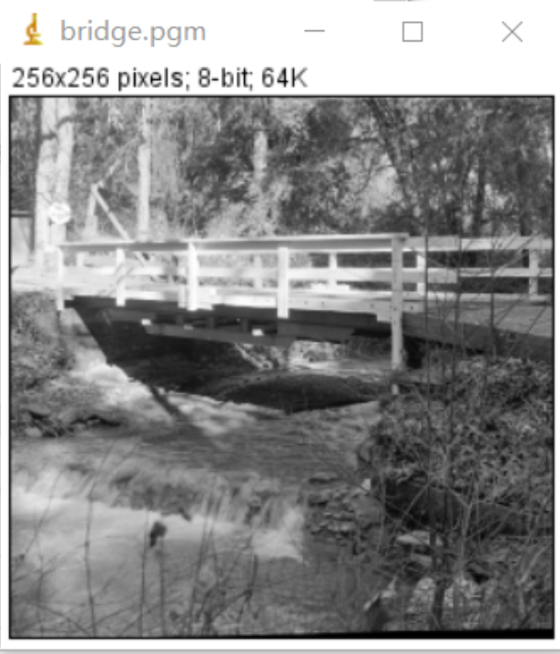

**Discussion:**

The image shear here is to first obtain the value of the miscutting, enlarge the width of the output image to (1+multiple) times, and then assign the points of the original image after the operation to the output image.

**Codes:**

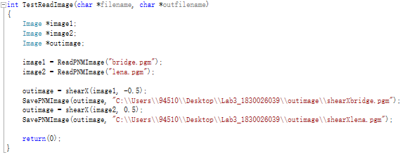

 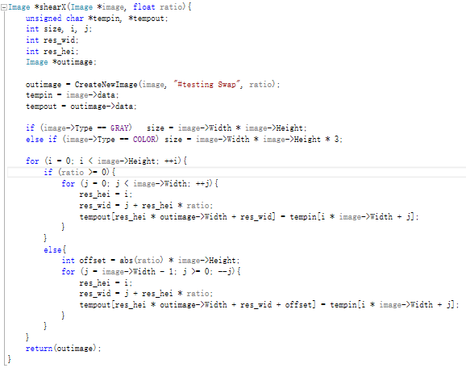

* Shear Y

**Algorithm:**

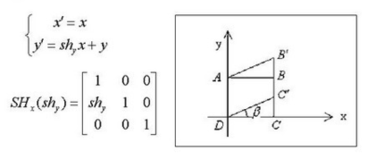

Enlarge the height.

ratio is the magnification you want to shear.

Outimageheight = inimageheight + inimagewidth * |ratio|

i = 0. i < imagewidth, i plus 1,

if ratio is greater than or equal to 0,

offset = |ratio| * imagewidth,

j = 0. j < imageheight, j plus 1,

res_w = i,

res_h =j + offset – res_w * ratio,

outimagedata[res_h*outimagewidth + res_w] = inimagedata[i * imagewidth +j]

else

j = imagewidth -1, if j is greater than or equal to 0, j minus 1,

res_w = i,

res_h = j + res_w * |ratio|,

outimagedata[res_h*outimagewidth+res_w+offset]=inimagedata[i * imagewidth +j]

**Results (including pictures):**

Result of processing “Lena.pgm”:

Source Image: Result after image shear Y (-0.5 times)

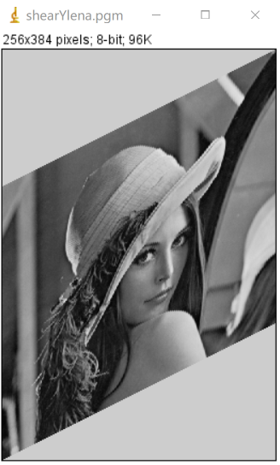

Result of processing “bridge.pgm”:

Source Image: Result after image shear Y: (0.5 times)

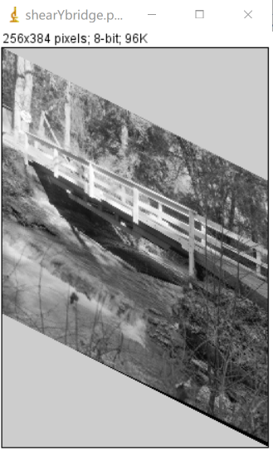

**Discussion:**

The image shear here is to first obtain the value of the miscutting, enlarge the height of the output image to (1+multiple) times, and then assign the points of the original image after the operation to the output image.

**Codes:**

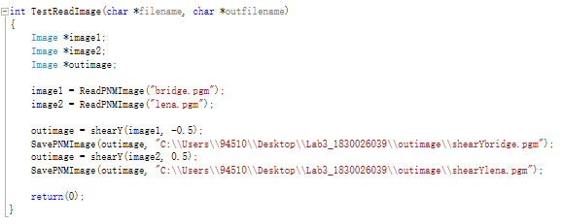



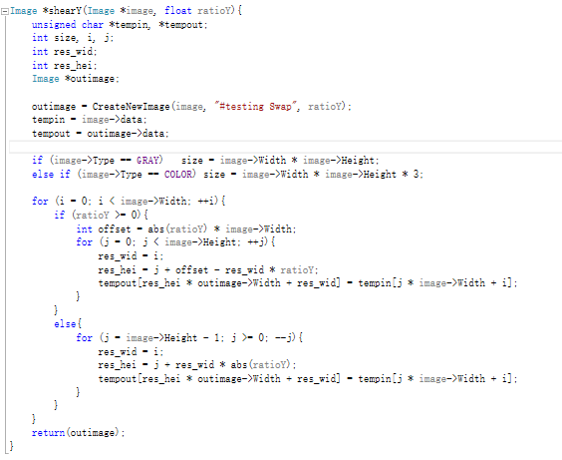

1. **Average filter:**

* 3 * 3 Average filter

**Algorithm:**

$outImage(i,j)=\sum_{k=-1}^{1}{\sum_{t=-1}^{1}{inImage(i+k,j+t)}}/9$ (1.1)

$indexInData = i*width+j$ (1.2)

$outData[i*width+j]=\sum_{k=-1}^{1}{\sum_{t=-1}^{1}{inData[(i+k)*width+(j+t)]}}/9$ (1.3)

**Results (including pictures):**

Result of processing “Lena.pgm”:

Source Image: Result after 3 * 3 average filter:

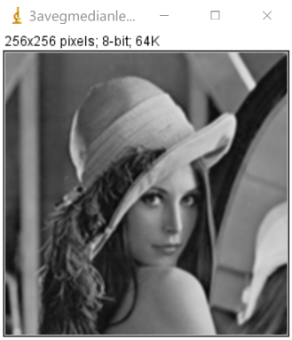

Result of processing “bridge.pgm”:

Source Image: Result after 3 * 3 average filter:

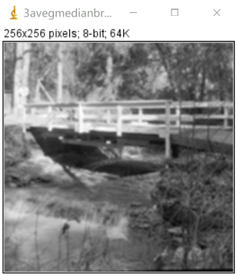

**Discussion:**

From equation (1.1), we can conclude that differences between neighbor pixels become smaller by averaging, which leads to the smoother of image.

The result images do turn out to be smoother. For example, the edges between objects are less obvious.

**Codes:**

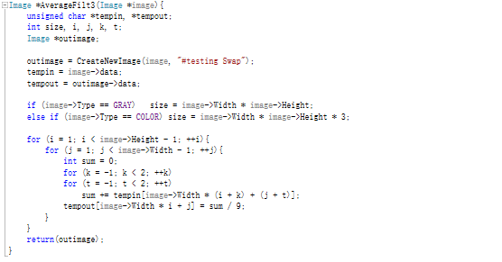

* 5 * 5 Average filter

**Algorithm:**

**(**5 * 5 Average filter is similar as 3 * 3 Average filter**)**

$outImage(i,j)=\sum_{k=-2}^{2}{\sum_{t=-2}^{2}{inImage(i+k,j+t)}}/25$ (1.1)

$indexInData = i*width+j$ (1.2)

$outData[i*width+j]=\sum_{k=-2}^{2}{\sum_{t=-2}^{2}{inData[(i+k)*width+(j+t)]}}/25$ (1.3)

**Results (including pictures):**

Result of processing “Lena.pgm”:

Source Image: Result after 3 * 3 average filter:

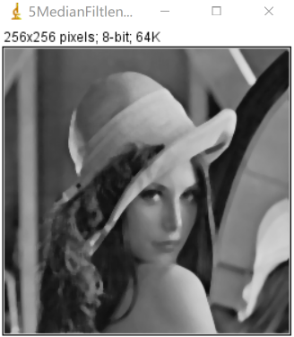

Result of processing “bridge.pgm”:

Source Image: Result after 3 * 3 average filter:

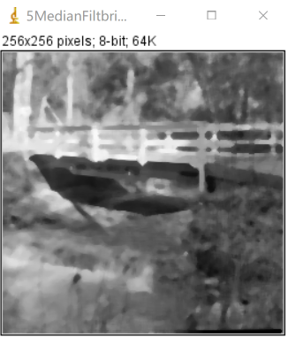

**Discussion:**

From equation (1.1), we can conclude that differences between neighbor pixels become smaller by averaging, which leads to the smoother of image. The result images do turn out to be smoother. For example, the edges between objects are less obvious.

**Codes:**

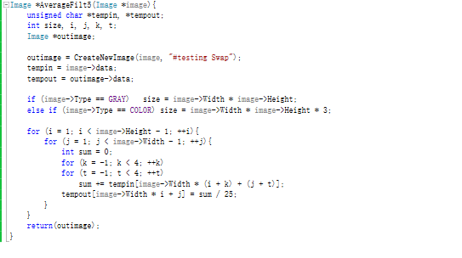

1. **Median filter**

* 3 * 3 median filter

**Algorithm:**

Input: a unsigned char array that stores the source image data

Output: a unsigned char array that stores the output image data

For inImage(i, j):

Store its’ 3 x 3 neighbor including itself in a unsigned char array **local**[9];

Find out the median of **local**;

Assign the median to outImage(i,j) => $outData[i*width+j]=findMedian(local,9)$

END

Function findMedian() use bubble sort to find the 5th smallest value of **local**.

**Results (including pictures):**

Result of processing “Lena.pgm”:

* Source Image: Result after 3 * 3 median filter:

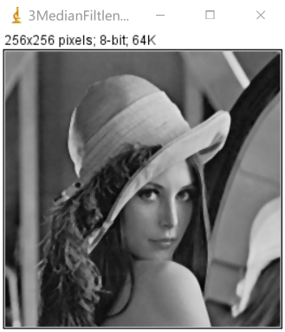

Result of processing “bridge.pgm”:

Source Image: Result after 3 * 3 median filter:

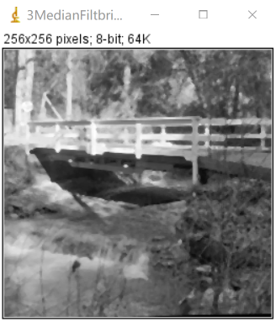

**Discussion:**

The median filter can also smooth the input image. But the result of the median filter is clearer than the result of the average filter. The median filter only replaces the target with the median value of the 3 x 3 neighbors, so this operation does not. Therefore, the difference between the values ​​in the median filter output image is greater than the difference in the average filter.

**Codes:**

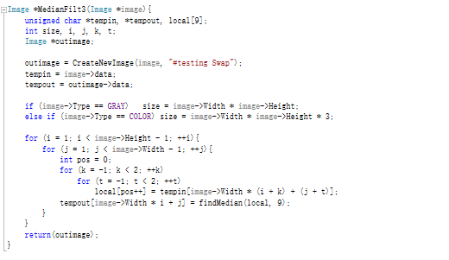

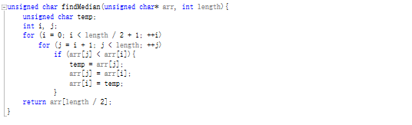

* 5 * 5 median filter

**Algorithm:**

**(**5 * 5 median filter is similar as 3 * 3 median filter**)**

Input: a unsigned char array that stores the source image data

Output: a unsigned char array that stores the output image data

For inImage(i, j):

Store its’ 5 x 5 neighbor including itself in a unsigned char array **local**[25];

Find out the median of **local**;

Assign the median to outImage(i,j) => $outData[i*width+j]=findMedian(local,25)$

END

Function findMedian() use bubble sort to find the 13th smallest value of **local**.

**Results (including pictures):**

Result of processing “Lena.pgm”:

Source Image: Result after 5 * 5 median filter:



Result of processing “bridge.pgm”:

Source Image: Result after 5 * 5 median filter:



**Discussion:**

The median filter can also smooth the input image. But the result of the median filter is clearer than the result of the average filter. The median filter only replaces the target with the median value of the 5 x 5 neighbors, so this operation does not. Therefore, the difference between the values ​​in the median filter output image is greater than the difference in the average filter.

**Codes:**

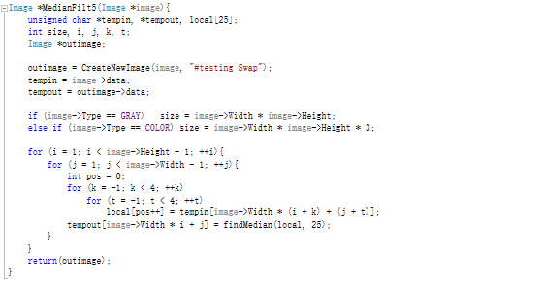



1. **Binarization**

* 3 * 3 binarization

**Algorithm:**

Input: a unsigned char array that stores the source image data

Output: a unsigned char array that stores the output image data

For binarization(i, j):

Store its’ 3 x 3 neighbor including itself in a unsigned char array **local**[9];

Find out the median of **local**;

$\operatorname{mid}{= }findMedian(local,9)$

Find out the maximum value of **local**;

$\max{= }findMax(local,9)$

Find out the minimum of **local**;

$\min{= }findMin(local,9)$

Check the value of inimagedata[i * imagewidth + j]:

If value is greater than or equal to mid, inimagedata = max,

else inimagedata = min

END

Function findMedian() use bubble sort to find the 5th smallest value of **local**.

Function findMax() is used to find the biggest value of **local**.

Function findMax() is used to find the smallest value of **local**.

**Results (including pictures):**

Result of processing “Lena.pgm”:

Source Image: Result after 3 * 3 binarization:

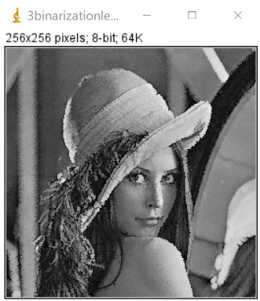

Result of processing “bridge.pgm”:

Source Image: Result after 3 * 3 binarization:

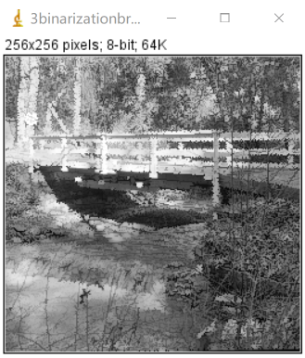

**Discussion:**

The image after binarization is not as clear as the image after median filtering. In binarization, each point traversed is judged whether it is greater than the median value. The new pixel of the pixel greater than or equal to the median value is the maximum value of this 3*3 block. The new pixel of the pixel smaller than the median value is the minimum value of this 3*3 block, which also causes a relatively large deviation because they have extreme value.

**Codes:**

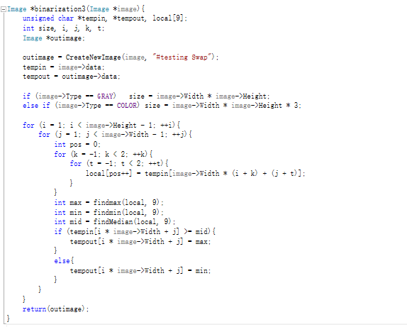

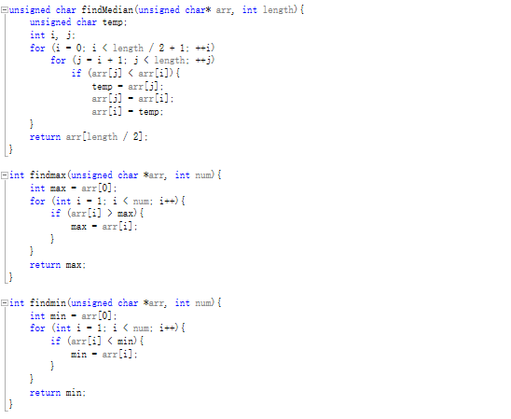

* 5 * 5 binarization

**Algorithm:**

**(**5 * 5 binarization is similar as 3 * 3 binarization**)**

Input: a unsigned char array that stores the source image data

Output: a unsigned char array that stores the output image data

For binarization(i, j):

Store its’ 5 x 5 neighbor including itself in a unsigned char array **local**[25];

Find out the median of **local**;

$\operatorname{mid}{= }findMedian(local,25)$

Find out the maximum value of **local**;

$\max{= }findMax(local,25)$

Find out the minimum of **local**;

$\min{= }findMin(local,25)$

Check the value of inimagedata[i * imagewidth + j]:

If value is greater than or equal to mid, inimagedata = max,

else

inimagedata = min

END

Function findMedian() use bubble sort to find the 13th smallest value of **local**.

Function findMax() is used to find the biggest value of **local**.

Function findMax() is used to find the smallest value of **local**.

**Results (including pictures):**

Result of processing “Lena.pgm”:

Source Image: Result after 5 * 5 binarization:

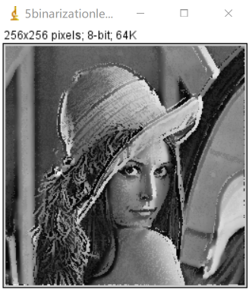

Result of processing “bridge.pgm”:

Source Image: Result after 5 * 5 binarization:

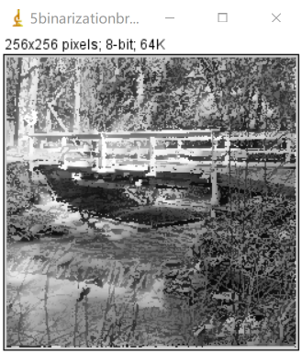

**Discussion:**

The image after binarization is not as clear as the image after median filtering. In binarization, each point traversed is judged whether it is greater than the median value. The new pixel of the pixel greater than or equal to the median value is the maximum value of this 3*3 block. The new pixel of the pixel smaller than the median value is the minimum value of this 3*3 block, which also causes a relatively large deviation because they have extreme value.

**Codes:**

